Experiment 1
Installation of Xampp

1) Download Xampp using wget command
wget https://downloadsapachefriends.global.ssl.fastly.net/xampp-files/7.2.1/xampp-linux-x64-7.2.1-0-installer.run?from_af=true
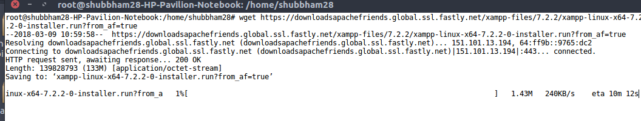
2) The Xampp file will be downloaded to the Downloads Folder. Open the Terminal. Type the following command in terminal to open file location
cd ~/Downloads
3) Run the following command to make it executable
chmod +x xampp-linux-x64-7.2.1-0-installer.run
4) To Install Xampp , Run the below command in terminal
./xampp-linux-x64-7.2.1-0-installer.run
5) After Few seconds a Pop-up Window will open . Install the xampp by clicking Next & Finish buttons when required. Once installaition is done .It will be installed in /opt/lampp directory.
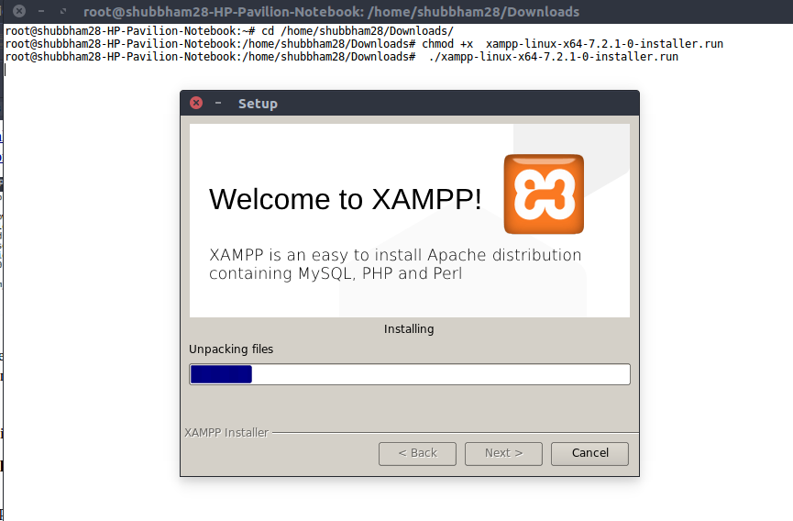

6) Now you can start Xampp services using the following command.
/opt/lampp/lampp start
7) To Stop the service using the following command
/opt/lampp/lampp stop
